**Explorify**

Explorify is a fantastic resource created by the Wellcome Trust for schools to support children in thinking scientifically.

This is one of their zoom in, zoom out activities. It starts with a very close up shot.

Think about these questions:

* What do you think the image is and why?
* What does the image remind you of and why?
* Can you describe the colours, textures and shapes?

*Be careful as the answer is revealed on the next page so don’t look until you are ready.*

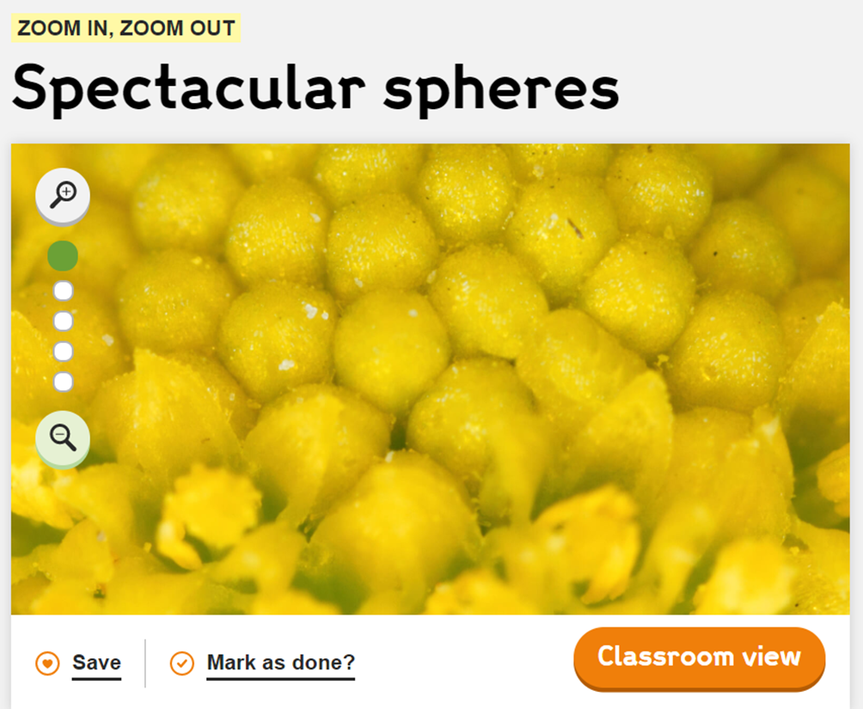



Answer: It is a daisy head.  This is often thought to be one piece; however, it is made up of many individual tiny flowers called disc flowers or florets.

There are lots of daisies around at the moment. Where have you seen them? Where do you think daisies prefer to grow?